

HealthCare: Persistency of a Drug

Data Science Internship Project

By:

Ashish Sasanapuri

Mohammad Shehzar Khan

Tomisin Abimbola Adeniyi

Noah Gallego

30/12/2023

**Table of contents**

List of Figures 3

1. Introduction 4

1.1 Problem Statement 4

1.2 Project Lifecycle 4

1.2.1 Research/Study 4

1.2.2 Data Processing 4

1.2.3 Model Building 4

1.2.4 Deployment 4

2. Methodology 5

2.1 Data Understanding 5

2.2 Data Pre-processing 5

2.2.1 Handling Missing Values/Outliers 5

2.2.2 Data Transformations 6

2.3 Exploratory Data Analysis (EDA) 6

2.3.1 Demographics 6

2.3.2 Physician Attributes 8

2.3.3 Clinical Factors 8

2.3.4 Disease/Treatment Factors 10

3. Model Building 12

3.1 Feature Selection 12

3.2 Learning Models 12

4. Results 12

4.1 Performance Metrics 12

5. Deployment 12

5.1 Application Building with Flask 12

5.2 Wrapping Flask framework with Docker 12

5.3 Cloud Deployment 12

6. Conclusion 12

References 13

# **List of Figures**

Figure 1: Box plot visualisation for before and after transformation of Dexa_Freq_During_Rx feature using Box-Cox method 7

Figure 2: Before and after transformation of Count_Of_Risks feature after handling outliers 7

Figure 3: Plots for Gender, Race and Ethnicity features 8

Figure 4: Age group distribution 8

Figure 5: Age distribution with respect to Region 8

Figure 6: Pie chart displaying Physician specialities 9

Figure 7: Physician specialities divided into 3 different categories 9

Figure 8: List of features with Unknown values 9

Figure 9: Glucocorticoids usage prior and during therapy 10

Figure 10: Plot showing patients taking DEXA scans during therapy 10

Figure 11: Risk factor distribution by persistency 10

Figure 12: Comorbidity factor distribution by persistency 11

Figure 13: Concomitant drugs provided to patients 11

Figure 14: Number of risks patients had at the same time 12

# 1. Introduction

## 1.1 Problem Statement

One challenge for all pharmaceutical companies is to understand the persistence of a drug as per the physician's prescription. To solve this problem ABC Pharma company approached an analytics company to automate this process of identification. The aim is to build a persistency prediction application that classifies patients persistent to New Medication Therapies (NTM) of the drugs prescribed by their respective physicians.

This application will help in studying and understanding the factors impacting a patient to be compliant or non-compliant to the prescribes treatment. Along with this, the application will also help in improving the persistency based on the understanding of the historical data presented by the Pharma company.

## 1.2 Project Lifecycle

The project flow is divided into different sections from transforming the data into understandable format and analysing the data assisting in building the machine learning model.

### 1.2.1 Research/Study

This section involves going through the problem statement for better understanding on the objective, researching different methods for feature and model selection.

### 1.2.2 Data Processing

The initial phase of this step involves cleaning the dataset for converting the data from unstructured to structured data, handling missing values and outliers. Post the pre-processing of the data, analysing the data for business impacting patterns is an important step that is carried out by Exploratory Data Analysis (EDA). The prime focus of this step is to understand the impact of different features with the target variable through visualisations and obtaining their importance for model training.

### 1.2.3 Model Building

Post exploration of the dataset, feature selection methods will be implemented to extract features that have potential impact on the machine learning model to be trained and also help in reducing complexity and dimensionality while improving performance of the model.

The model selection step is carried out by comparing the performance of different models by implementing different performance metrics such as Accuracy, Precision, Recall and F1-score.

### 1.2.4 Deployment

The aim is to develop an application using Flask to create APIs for calling the model, perform the prediction and displaying the result on the application page. The application is then wrapped in a container using Docker for easy virtualisation and deployment of the application irrespective of the environment and running via a single command run.

This containerised application is hosted on a cloud environment that helps in providing abstract environment consisting of various services and network security for running the application.

# 2. Methodology

This section describes the dataset used in detail and explains the methodologies adopted to handle issues with the dataset. The sub-sections provide details regarding the pre-processing and analysis of the data.

## 2.1 Data Understanding

The dataset used is a Healthcare dataset containing medical attributes corresponding to persistency of each patient to New Therapy Medication (NTM) by the ABC’s Pharmaceutical company. The dataset consists of 3242 records of patients and 69 different features described as below:

* 1 Target variable: *Persistency_Flag*
* 1 Unique identifier for each patient: *Ptid*
* 6 Demographic variables of each patient: *Age_Bucket*, *Gender*, *Race*, *Ethnicity*, *Region*, *Idn_Indicator*.
* 3 Physician Specialist attributes: *Ntm_Speciality*, *Ntm_Specialist_Flag*, *Ntm_Specialist_Bucket*.
* 13 Clinical factors: *T-Score* details, *Risk_Segment* details, *Multiple risk factors count*, *DEXA* details, *Fragility fracture* details, *Glucocorticoid* details.
* 45 Disease/Treatment factors: *Injectable drugs*, *Risk factors*, *Comorbidities*, *Concomitancies*, *Adherence to therapy*.

There 2 types of data points in the dataset – numerical and categorical. Out of these 69 features, two features *Dexa_Freq_During_Rx* and *Count_Of_Risks* are numerical features and the rest are categorical features.

## 2.2 Data Pre-processing

### 2.2.1 Handling Missing Values/Outliers

There were no missing values in the dataset. Given that there were only two numerical features, we specifically examined outliers for these features. The methods used to detect outliers were Boxplot visualization, Histogram, Interquartile Range (IQR) and Z-score.

Both of the features exhibited outliers, and the data distribution demonstrated a positive skew. To overcome inaccurate insights and decisions from the dataset, the outliers were handled via following techniques:

* *Box-Cox Transformation* – It tries to stabilize the variance in the data and improves the distribution of data to normal.
* *Log Transformation* – Applying log to data points changes the values but also help reduce skewness in the data.
* *Square Root Transformation* – Takes the square root of each data point helping with skewness of the data and converting into normal distribution.
* *Winsorization* – This helps cap the outliers with the upper and lower bound limits obtained from *IQR*.

Among the mentioned methods, *Box-Cox transformation*, Figure 1, obtained better results at handling the outliers most efficiently.

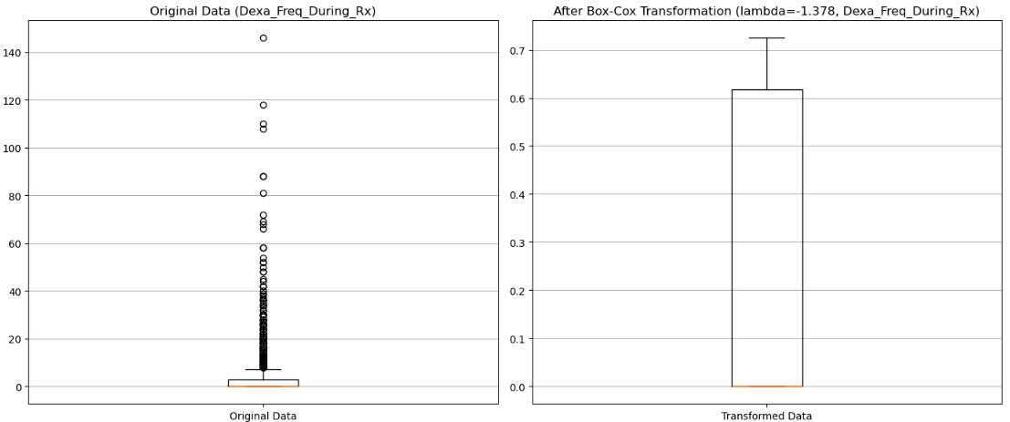

Figure : Box plot visualisation for before and after transformation of Dexa_Freq_During_Rx feature using Box-Cox method

For the *Count_Of_Risks* feature, as the categories are unique number of risks per patient the outliers were handled by reducing the categories to 0, 1, 2, >=3, Figure 2.

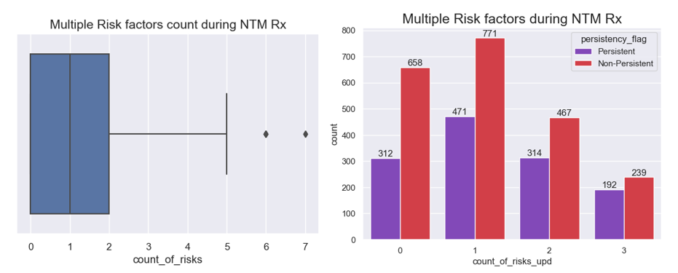

Figure : Before and after transformation of Count_Of_Risks feature after handling outliers

### 2.2.2 Data Transformations

Data transformation is one of the important sections when feeding the data to the machine learning model for training. As the machine learning models only understand numerical data, majority of features consisting of categorical data is converted into numerical data type using LabelEncoder library of SciKit Learn.

## 2.3 Exploratory Data Analysis (EDA)

Understanding the dataset is one of the most important and challenging tasks in machine learning. Exploring the data will help in gaining insights and making sense of the data which will guide us through selecting relevant features that impact the performance of the model and generate better results for testing new data points. This section will explore the steps performed to visualize the data to generate patterns in the data.

### 2.3.1 Demographics

This section describes the demographics of each patient such as *Age*, *Gender*, *Region*, *Race*, and *Ethnicity*. The features such as *Gender*, *Race* and *Ethnicity* don’t provide much information when compared with the target variable, *Persistency_flag*, Figure 3.

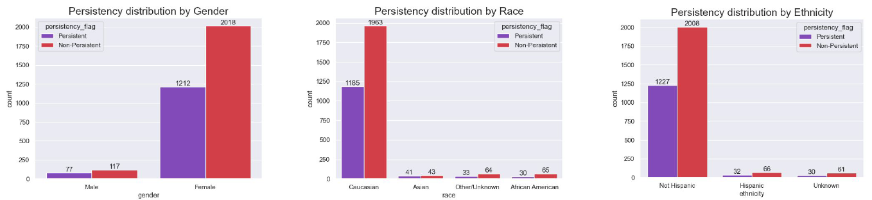

Figure : Plots for Gender, Race and Ethnicity features

The *Age_Bucket* feature shows the age groups of different patients recorded in the dataset. Based on the observations from the plot, Figure 4, the majority of patients recorded are above 55 years of age and most **Non-persistent** patients belong to the category of above 75 years of age.

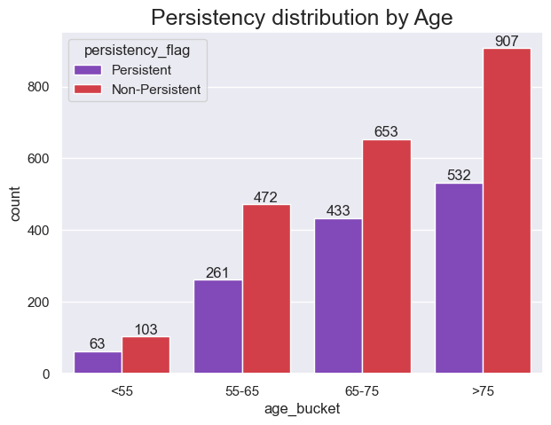

Figure : Age group distribution

A distribution of age brackets can also be observed with respect to the regions in the United States, Figure 5, where most of the patients belong to **Midwest** or **South** regions.

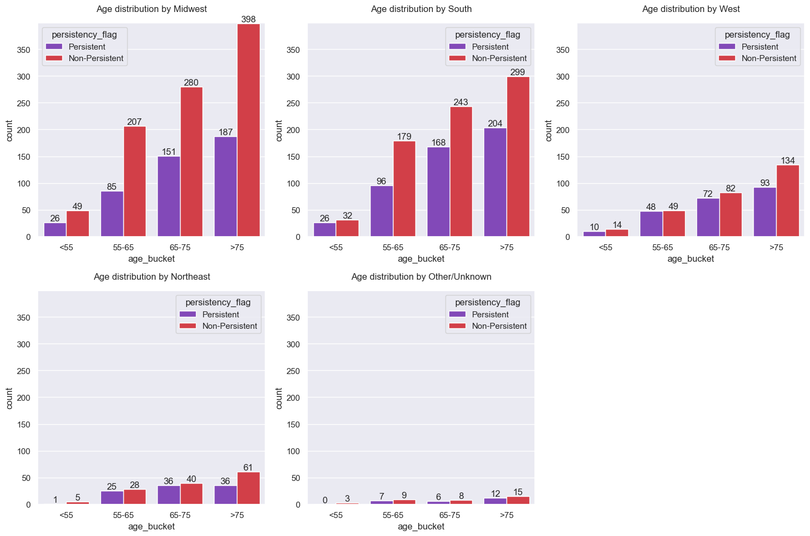

Figure : Age distribution with respect to Region

### 2.3.2 Physician Attributes

The physician attributes provide information regarding the speciality of physicians who prescribed the NTM to the patients. A total of 36 different physicians can be observed from Figure 6. Around *45%* of the physicians belong to **General Practitioner** category.

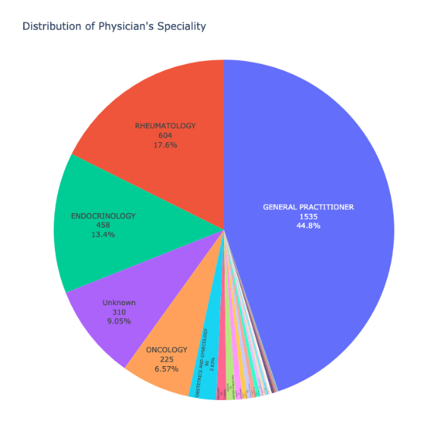

Figure : Pie chart displaying Physician specialities

One of the other attributes which combines these specialities into 3 different categories provides a significant distribution when compared with the target feature, Figure 7. Majority of patients are **Non-persistent** and have been prescribed by *non-specialists*.

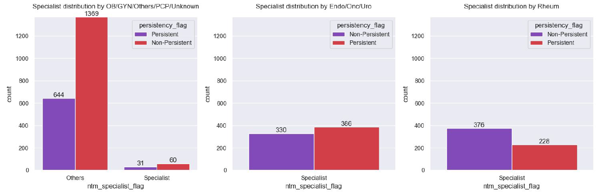

Figure : Physician specialities divided into 3 different categories

### 2.3.3 Clinical Factors

The clinical factors describe the factors such as DEXA scans carried out by patients, Fragility fractures of the patients, Bone density obtained from the DEXA scans, and the usage of Glucocorticoids by patients prior and during therapy. Although some of the features which have been recorded during the therapy have ‘Unknown’ values as evident in Figure 8.

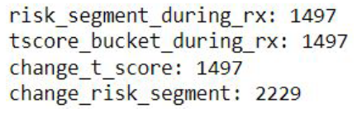

Figure : List of features with Unknown values

Considering the usage of Glucocorticoids, the number of **Persistent** patients is less as compared to **Non-persistent** category patients prior to the therapy. However, the case is vice-versa during the therapy as observed from the plot in Figure 9.

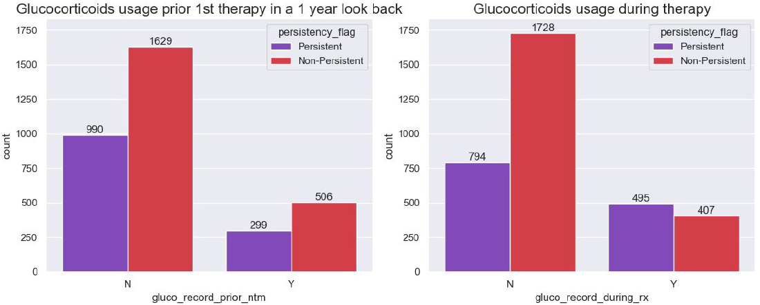

Figure : Glucocorticoids usage prior and during therapy

The *DEXA scans* prescribed to patients are the tests carried out to check the bone density of the patients after a Fragility Fracture or other factors. Most of the patients who haven’t taken these tests majorly fall under **Non-persistent** category, Figure 10.

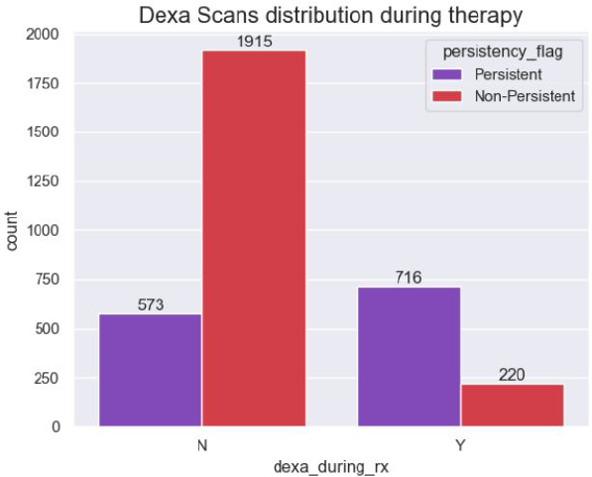

Figure : Plot showing patients taking DEXA scans during therapy

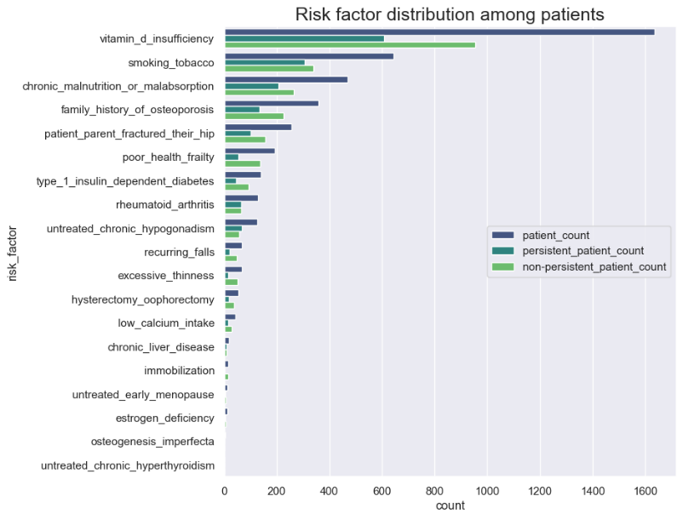

Figure : Risk factor distribution by persistency

### 2.3.4 Disease/Treatment Factors

This section details the different types of risks and comorbidities occurred to patients along with the concomitant drugs provided to the patients in a 1 year look back from the 1st NTM therapy.

Majority of patients have been susceptible to *Risk Factors* such as *Vitamin D deficiency*, *Smoking tobacco*, *Chronic malnutrition or malabsorption* and a *Family history of osteoporosis* as observed from Figure 11.

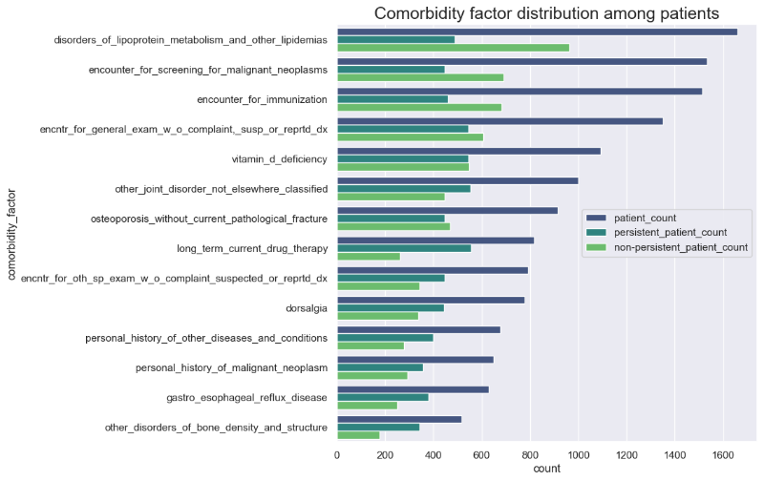

Figure : Comorbidity factor distribution by persistency

The *Comorbidities* of the patients recorded in the dataset are the occurrence of more than one disease or condition at the same time prior to the 1st therapy. There are a total of 14 *Comorbidities* as show in Figure 12.

*Concomitant* drugs are 2 or more drugs given to patients at the same time. The number of **Non-persistent** patients given *Concomitant* drugs such as *narcotics*, *Cholesterol and Triglyceride*, *systematic corticosteroids* and *Anti-depressants or mood stabilisers* prior to 1st therapy are greater in comparison to **Persistent** patients as evident from Figure 13.

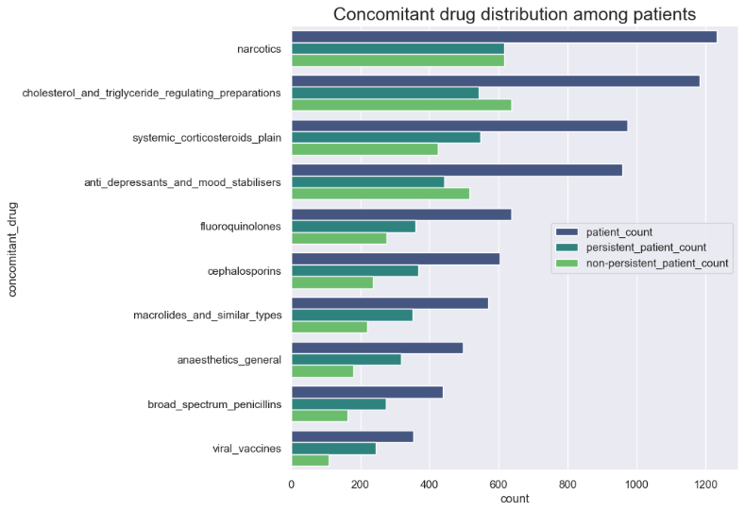

Figure : Concomitant drugs provided to patients

Figure 14 shows the number of risk factors patients had at the same time. As the number of risks at the same time increases, the count of patients decreases.

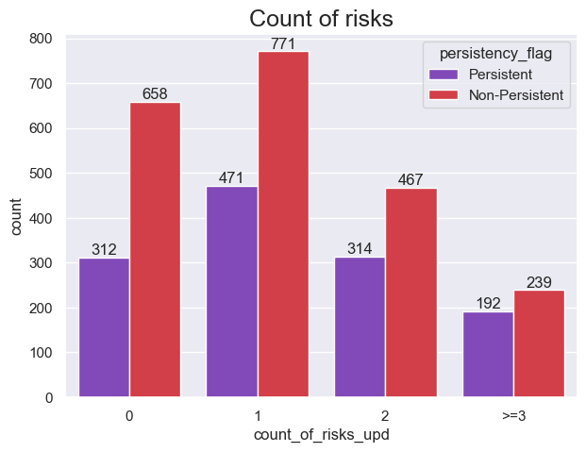

Figure : Number of risks patients had at the same time

# 3. Model Building

This section introduces the feature selection methods and machine learning models used in this project to train the dataset.

## 3.1 Feature Selection

## 3.2 Learning Models

# 4. Results

## 4.1 Performance Metrics

# 5. Deployment

The deployment section describes the building of the web page that takes inputs from the user, using Flask and Docker for creating APIs and containerising the application for hosting the application on cloud for easy and remote access irrespective of the underlying environment.

## 5.1 Application Building with Flask

Implementing the Flask framework requires a HTML page for the input by end user, an API for accessing the form values and passing the result through the form to the HTML page for displaying the prediction result. The prediction result is calculated using the saved trained model.

In this project’s scenario, below are 4 different files helping in fulfilling the above requirements –

* *Healthcare_final.ipynb* – This python notebook generates the trained and evaluated Logistic Regression model.
* *app*.py – This python file acts as the interface for access form values and using these values to predict the result by loading the Logistic Regression model.
* *home.html* – The webpage required for access by the end users and also displays the prediction result.
* *style.css* – The style sheet for building an interactive and easy to use interface web page.

## 5.2 Wrapping Flask framework with Docker

## 5.3 Cloud Deployment

# 6. Conclusion

# References

[1] "History of Banking." Wikipedia. <https://en.wikipedia.org/wiki/History_of_banking> (accessed.

[2] "The History of Lending." Provenir. <https://www.provenir.com/resources/collateral/history-of-lending/> (accessed.

[3] M. Aslam, "Predicting Likelihood for Loan Default Among Bank Borrowers," *International Journal of Financial Research,* vol. 11(1), 2019, doi: <https://doi.org/10.5430/ijfr.v11n1p318>.

[4] M. Madaan, A. Kumar, C. Keshri, R. Jain, and P. Nagrath, "Loan default prediction using decision trees and random forest: A comparative study," in *IOP Conference Series: Materials Science and Engineering*, 2021, vol. 1022, no. 1: IOP Publishing, p. 012042.

[5] S. K. Shaheen and E. ElFakharany, "Predictive analytics for loan default in banking sector using machine learning techniques," in *2018 28th International Conference on Computer Theory and Applications (ICCTA)*, 2018: IEEE, pp. 66-71.

[6] L. Lai, "Loan default prediction with machine learning techniques," in *2020 International Conference on Computer Communication and Network Security (CCNS)*, 2020: IEEE, pp. 5-9.

[7] P. M. Addo, D. Guegan, and B. Hassani, "Credit risk analysis using machine and deep learning models," *Risks,* vol. 6, no. 2, p. 38, 2018.

[8] N. George. "All Lending Club loan data." Kaggle. <https://www.kaggle.com/datasets/wordsforthewise/lending-club> (accessed.

[9] H. Bonthu. "Detecting and Treating Outliers | Treating the odd one out!" Ananlytics Vidhya. <https://www.analyticsvidhya.com/blog/2021/05/detecting-and-treating-outliers-treating-the-odd-one-out/> (accessed.

[10] M. L. Waskom, "Seaborn: statistical data visualization," *Journal of Open Source Software,* vol. 6, no. 60, p. 3021, 2021.

[11] G. Hemming. "Open Credit." ABC Finance Ltd. <https://abcfinance.co.uk/credit/open/> (accessed.

[12] "The Meaning of “Derogatory Public Record”." Experian. <https://www.experian.com/blogs/ask-experian/meaning-of-derogatory-public-record/#:~:text=A%20derogatory%20item%20is%20an,were%20not%20paid%20as%20agreed> (accessed.

[13] L. DOWNEY. "Derogatory Information." Investopedia. <https://www.investopedia.com/terms/d/derogatory-information.asp> (accessed.

[14] A. HAYES. "FICO Score." Investopedia. <https://www.investopedia.com/terms/f/ficoscore.asp> (accessed.

[15] "What Is Revolving Credit and How Does It Work?" Capital One. <https://www.capitalone.com/learn-grow/money-management/revolving-credit-balance/> (accessed.

[16] A. Saini. "Conceptual Understanding of Logistic Regression for Data Science Beginners." Analytics Vidhya. <https://www.analyticsvidhya.com/blog/2021/08/conceptual-understanding-of-logistic-regression-for-data-science-beginners/> (accessed.

[17] S. T. "Entropy: How Decision Trees Make Decisions." Towards Data Science. <https://towardsdatascience.com/entropy-how-decision-trees-make-decisions-2946b9c18c8> (accessed.

[18] T. Yiu. "Understanding Random Forest." Towards Data Science. <https://towardsdatascience.com/understanding-random-forest-58381e0602d2> (accessed.

[19] S. E. R, "Understanding Random Forest," ed: Analytics Vidhya, 2021.

[20] V. Morde. "XGBoost Algorithm: Long May She Reign!" Towards Data Science. <https://towardsdatascience.com/https-medium-com-vishalmorde-xgboost-algorithm-long-she-may-rein-edd9f99be63d> (accessed.